**A Mobile Application for Diagnosing Celiac Disease using Gradient Boosting Algorithm**

A Thesis Proposal  
Presented to the Faculty of the  
College of Computer and Information Sciences  
Polytechnic University of the Philippines

In Partial Fulfilment  
of the Requirements for the Degree

Bachelor of Science in Computer Science

Baleta, Gabriel Mori

Pajanustan, Joven

# CHAPTER 1 The Problem and Its Background

This chapter mainly discusses the background of the study, statement of the problem, the conceptual framework and the scope and limitation about the research. It also includes the introduction, hypothesis, significance of the study and the definition of terms used. It does provide information the conceptualization of this study.

## INTRODUCTION

Celiac disease (CD) is an autoimmune disorder that’s triggered by eating gluten-containing food such as bread products. Gluten-containing food damages the intestinal villi of people with CD, which results in impaired absorption of nutrients and its consequences, i.e., malnutrition, osteoporosis, and iron deficiency. Chronic injury to the villi also increases the risk of intestinal lymphomas (a type of cancer) in people with CD (Gonzales, March 2017).

Gradient boosting is a machine learning technique for regression and classification problems, which produces a prediction model in the form of an ensemble of weak prediction models, typically decision trees. It builds the model in a stage-wise fashion like other boosting methods do, and it generalizes them by allowing optimization of an arbitrary differentiable loss function (Cossock, et al. ,2008).

A Mobile Application for Diagnosing Celiac Disease using Gradient Boosting Algorithm is an android application that evaluates a user’s risk on having Celiac Disease based on their symptoms and set of risk factors. The application outputs the percentage of risk of the user and interprets whether the user is at classical celiac disease, non-classic celiac disease, or silent celiac disease.

* 1. **BACKGROUND OF THE STUDY**

This Celiac disease can be difficult to diagnose because it affects people differently. There are more than 200 known celiac disease symptoms which may occur in the digestive system or other parts of the body. Some people develop celiac disease as a child, others as an adult.

When people with celiac disease eat gluten (a protein found in wheat, rye and barley), their body mounts an immune response that attacks the small intestine. These attacks lead to damage on the villi, small fingerlike projections that line the small intestine, that promote nutrient absorption. When the villi get damaged, nutrients cannot be absorbed properly into the body.

Celiac disease is hereditary, meaning that it runs in families. People with a first-degree relative with celiac disease (parent, child, sibling) have a 1 in 10 risks of developing celiac disease.

Celiac disease is very dangerous so that if there is a way to determine if person have it better do it. In this modern era smartphones are available in the market with its affordable price, the researchers realized that this will be a helpful application for the community, because through mobile application a person can determine if he/she have a high chance of having a celiac disease, because early diagnosis of a patient’s illness will have a high chance of survivability.

**1.3 THEORETICAL FRAMEWORK**

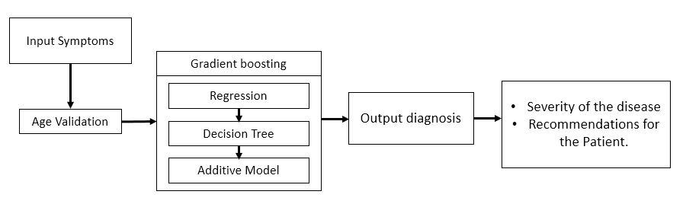

Figure 1.1 theoretical framework of the system

**1.4 STATEMENT OF THE PROBLEM**

The study aims to develop and implement a system that will diagnose if a person has a celiac disease. In addition to this, the researchers intend to answer the following questions:

1. What is the accuracy of the system in diagnosing if a person has a celiac disease in terms of the following symptoms:

a. Behavioral or Central Nervous System Conditions

ADHD

Anxiety

Foggy Mind

Depression

Developmental Delay

Headache or Migraine

Irritability

Ataxia

Seizure

b. Gastrointestinal Conditions

Abdominal Pain

Acid Reflux(Heartburn)

Bloating

Constipation

Diarrhea

Lactose Intolerance

Intestinal Cancer

Foul-smelling Stool

Vomiting

Weight Loss or Weight Gain

c. Muscular Skeletal Conditions

Arthritis

Bone or Joint Pain

Muscle Pain

Numbness or Pain in hands

Osteoporosis

Short Stature

d. Reproductive Conditions

Delayed Puberty

Infertility

Menstrual Irregularities

Miscarriage

e. Skin and Dental Conditions

Discolored teeth or enamel loss

Eczema

Itchy Skin Rash (Dermatitis Herpetiformis)

Loss of hair in body (Alopecia)

Recurrent Mouth Canker Sores/Oral Ulcers (Aphthous Stomatitis)

**1.5 OBJECTIVES OF THE STUDY**

* To measure the level of accuracy of the system in diagnosing if a person has a celiac disease.

**1.6 CONCEPTUAL FRAMEWORK**

The figure 1.2 below illustrates the conceptual framework of the system. The needed tools for the system are shown below. First, in the input phase, the user needs to answer the questions for symptoms. In the process phase includes the validation phase wherein only ages 18 and above can use this system then Gradient Boosting phase, where the data given will converted into numerical value first to process that will give the output of the system which will be the possible initial Celiac Disease diagnosis or the type of it.

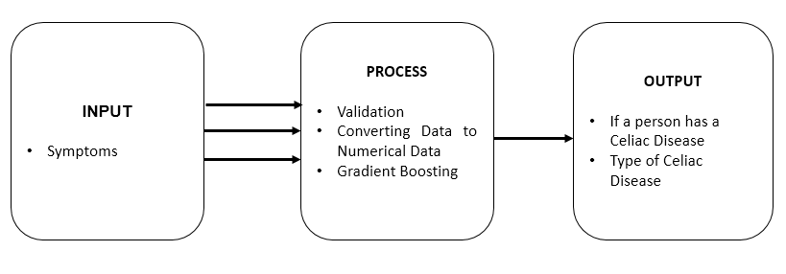

Figure 1.2 Conceptual Framework of the system

**1.7 SCOPE AND LIMITATIONS**

This system has the capacity to diagnose if the user has a Celiac Disease and the type of celiac disease only. The age input has a range from 18 years old and above only. The system has no capability of recommending an initial treatment. Although the research has reached its aims, there are still some unavoidable limitations. First, because of the limited time given, the research was conducted only on a small size of population.

**1.8 SIGNIFICANCE OF THE STUDY**

**Celiac Disease Patients**

This can be beneficial to the patients with Celiac disease for the early diagnosis. This can also help them decide to have an immediate consultation with the physician.

**Non-Celiac Disease Patients**

This can be beneficial to the patients without Celiac disease to determine if they have it and immediately consult a physician.

**Celiac Disease Experts**

The developed application will be a useful tool to give assistance for the experts in Celiac Disease. The tool can be used as an initial test / initial screening for their first-time patients to assess them if they are already at risk of having Celiac Disease.

**Future Researchers**

This will help the future researchers with the same topic of interest. This will also serve as guide or reference for them especially on the topics related to diagnosing of Celiac Disease.

**1.9 DEFINITION OF TERMS**

*Celiac Disease* - is a serious autoimmune disorder that can occur in genetically predisposed people where the ingestion of gluten leads to damage in the small intestine.

*Gradient Boosting* - is a machine learning technique for [regression](https://en.m.wikipedia.org/wiki/Regression_(machine_learning)) and [classification](https://en.m.wikipedia.org/wiki/Classification_(machine_learning)) problems, which produces a prediction model in the form of an [ensemble](https://en.m.wikipedia.org/wiki/Ensemble_learning) of weak prediction models, typically [decision trees](https://en.m.wikipedia.org/wiki/Decision_tree_learning).

*Android* – is a mobile operating system developed by Google. It is used by several smartphones and tablets. Examples include the Sony Xperia, the Samsung Galaxy, and the Google Nexus One. The Android operating system (OS) is based on the Linux kernel.

*Mobile Application* - most commonly referred to as an app, is a type of application software designed to run on a mobile device, such as a smartphone or tablet computer. Mobile applications frequently serve to provide users with similar services to those accessed on PCs.

*Ataxia* - is a [neurological sign](https://en.wikipedia.org/wiki/Neurological_sign) consisting of lack of voluntary [coordination of muscle movements](https://en.wikipedia.org/wiki/Motor_coordination) that includes [gait abnormality](https://en.wikipedia.org/wiki/Gait_abnormality). Ataxia is a non-specific clinical manifestation implying dysfunction of the parts of the [nervous system](https://en.wikipedia.org/wiki/Nervous_system) that coordinate movement, such as the [cerebellum](https://en.wikipedia.org/wiki/Cerebellum).

*Anemia* - is a condition that develops when your blood lacks enough healthy red blood cells or hemoglobin.

*ADHD* – or attention deficit hyperactivity disorder, is a chronic condition marked by persistent inattention, hyperactivity, and sometimes impulsivity. ADHD begins in childhood and often lasts into adulthood.

*Acid Reflux* - a condition in which acidic gastric fluid is regurgitated into the esophagus, causing heartburn.

*Lactose Intolerance* - means the body cannot easily digest lactose, a type of natural sugar found in milk and dairy products.

*Arthritis* - it is an informal way of referring to joint pain or joint disease.

*Osteoporosis* - a medical condition in which the bones become brittle and fragile from loss of tissue, typically because of hormonal changes, or deficiency of calcium or vitamin D.

*Eczema* - a medical condition in which patches of skin become rough and inflamed, with blisters that cause itching and bleeding, sometimes resulting from a reaction to irritation (eczematous dermatitis) but more typically having no obvious external cause.